Topic: Final Portfolio Project - Lessons Learned Reflection and UML Diagram for ATM

Tripti Vishwakarma
Colorado State University Global
Course Code: CSC 505-1
Jonathan Vanover
July 07 2024

Lessons Learned Reflection-

This course provided me with an integrated and detailed approach to programming and software development principles. I gained an understanding of object-oriented software programming and relevant software development principles. In this course I learned core programming concepts, data structures, methods, classes, and software models.

I learned that software is a complex entity, not just limited to programs or code. It includes executable programming code, related libraries, and documentation, all created to fulfill specific user needs and achieve defined objectives, culminating in what we call a software product. The module's objectives pushed me to evaluate the true nature of software, explore its formal definition, and scrutinize the processes and practices within software engineering.

I learned that the definition of software can vary, even among professionals. It's essential to understand that software possesses unique attributes: it's logical, doesn't physically degrade, and generally has a lower failure rate than hardware. This understanding is crucial for grasping the essence of software.

The course introduced me to the seven broad categories of computer software, which include system software, application software, engineering/scientific software, embedded software, product-line software, web/mobile applications, and artificial-intelligence software. Each category has its own set of characteristics and applications.

I learned about the different software engineering processes used to manage development. Some models are linear, while others are iterative, with each iteration bringing a completer and more refined version of the software.

I also learned about common problems in software development, such as misinterpreting user needs, handling changing requirements, module incompatibility, maintenance difficulties, late discovery of project flaws, poor quality, and inadequate performance. Understanding these issues is vital for developing strategies to produce and maintain quality software. The course taught me best practices to address these challenges, including iterative development, managing requirements, using component-based architectures, visually modeling software, verifying quality, and controlling changes to software. These practices are proven to be effective in the industry and are essential for successful software development.

I learned that before embarking on a software project, it's essential to define a task set, which details the work needed to meet the objectives of the software engineering effort. Understanding the task set is a critical part of the communication phase, ensuring that the software team and stakeholders are aligned on the project's goals.

For larger projects, a comprehensive task set is necessary. This includes identifying stakeholders, interviewing them to capture their needs, drafting a preliminary list of functions and features, holding specification meetings, creating user scenarios, refining these scenarios with stakeholder feedback, revising requirements, prioritizing them, planning for incremental delivery, noting constraints, and discussing validation methods.

Conversely, smaller projects may require a more streamlined task set. This typically involves identifying stakeholders, holding an informal meeting, listing desired features and functions, finalizing requirements, prioritizing them, and acknowledging uncertainties.

I also learned about the waterfall model, a linear approach to software development that progresses through stages of requirements specification, planning, modeling, construction, deployment, and maintenance. Each stage has defined activities and deliverables, from gathering customer requirements to deploying the finished software. However, the waterfall model's rigidity, particularly its reliance on upfront, detailed requirements, has led to its decline in popularity, as it struggles to accommodate changes once the project is underway.

Prototyping emerged as a valuable concept I learned about. It's a method where a working model of the software is built and refined iteratively. This is especially useful when customer goals are broad, allowing the development team to clarify detailed requirements through iterative cycles of planning, modeling, designing, prototyping, deploying, delivering, and gathering feedback.

Prototyping can be a standalone process or part of other models, offering a way to better understand requirements and adapt to changes throughout the development lifecycle. I learned that this flexibility is a significant advantage, as it allows for ongoing refinement and adjustment in response to feedback and evolving project needs.

In addition to these insights, I learned about the advantages and disadvantages of each model, which has equipped me with a deeper understanding of how to choose and apply the most appropriate software development process for a given project.
I learned that the Agile process is a pivotal methodology in software engineering, prioritizing stakeholder engagement and iterative development. It starts with clients outlining the intended use and benefits of the product, which informs the project team's understanding of client expectations.

Within Agile, I discovered that the Scrum framework is particularly effective for managing complex projects. Scrum breaks down the development process into sprints—short, focused periods of work followed by review and adaptation. This framework facilitates a high level of adaptability and results in the delivery of valuable and efficient products. Scrum's popularity is due in part to its alignment with the Agile Manifesto, guiding development through stages such as requirements, analysis, design, evolution, and delivery.

I learned about the importance of prototypes in Agile. They serve as early versions of the software, helping to clarify the project's direction by moving from broad objectives to detailed developer requirements. The initial prototype is crucial as it demonstrates the viability of the architectural design and sets the stage for parallel progress in requirements engineering, design, and development.

Testing emerged as a critical component of the development process, especially when evaluating prototypes. It verifies that the prototype functions as expected, although it is not designed to catch every defect. User involvement in testing is vital, as their feedback influences decisions on whether to continue with development. Risk assessment regarding cost and delivery timelines also plays a role in these decisions.

I gained insight into the optimal strategies for obtaining feedback on prototypes. Creating an encouraging setting for feedback, carefully choosing individuals for prototype testing, posing pertinent questions, maintaining objectivity when offering choices, adjusting to feedback during testing phases, and inviting users to contribute their thoughts. Employing phrases such as "I like," "I wish," and "What if?" empowers users to give positive reinforcement and propose creative enhancements. These practices are crucial for the iterative refinement of the prototype and for guiding the progression of the software development.

I learned that the success of software projects is heavily influenced by human factors, not just technical ones. Skilled and motivated individuals are essential for project success, as software development is fundamentally a human-centric activity.

The module taught me that a great software engineer possesses traits beyond technical knowledge, such as individual responsibility, awareness, honesty, resilience, fairness, attention to detail, and pragmatism. These traits are crucial for solving complex problems and collaborating effectively within a team.

I also learned that teamwork, underpinned by trust and a shared philosophy, is vital for software development success. Teams should establish performance management techniques to hold members accountable and provide timely feedback.

Regarding team structure, I learned that it varies but should consistently include a technical lead and a project manager. Factors like project complexity, size, duration, modularity, reliability, delivery date, and communication needs are important when defining a team's structure.

I learned about the impact of globalization on software development, with distributed teams facing challenges like communication barriers and cultural differences. Social media has become an essential tool for collaboration and coordination among global teams, sometimes rivaling the importance of face-to-face communication.

I learned the importance of accurately understanding and modeling software requirements, which are essential as they outline user expectations and can range from obvious to subtle. Requirements engineering was highlighted as a key process that connects the initial design with the final construction of software, involving tasks like inception and requirements management that can be done concurrently.
I learned that requirements gathering is a collaborative effort among stakeholders, managers, and engineers, aimed at defining problems and solutions through structured meetings, leading to usage scenarios that illustrate how users will interact with the software.

I learned that use cases are essential for mapping out user-system interactions, involving defining roles and simulating expected interactions

I learned about various analysis models as evolving representations of a system's informational, functional, and behavioral aspects, changing as more is learned about stakeholder needs.

I learned about various modeling techniques, including scenario-based and class-oriented models, crucial for translating requirements into detailed software designs. The UML Class model is particularly significant during the implementation phase for designing system classes and objects.

I learned that robust software design is rooted in a set of principles, concepts, and practices that lead to the creation of a high-quality system. I understood that design principles form an overarching philosophy that guides a developer's work, and these principles must be grasped before applying the mechanics of design practice. The design process itself is iterative, transforming requirements into a software blueprint, akin to a house blueprint, which provides both an abstract and detailed view of the system.

I learned that the design process is repetitive and demands patience and attention to detail. Following the analysis phase, the design phases iterate to refine the blueprint, ensuring that it aligns with the initial requirements. Quality assurance plays a crucial role throughout the design process, ensuring that all explicit and implicit requirements are included, the design is understandable, and it accurately reflects the data, functional, and behavioral domains from an implementation perspective.

The module taught me that a good design should exhibit a clear architecture, be modular, have distinct representations of data, architecture, interface, and components, and be derived using a repeatable method. It should also be represented in a notation that effectively communicates its meaning.

I learned that design concepts have evolved over time but still provide a foundation for more sophisticated methods. These concepts include abstraction, software architecture, design patterns, separation of concerns, modularity, information hiding, functional independence, stepwise refinement, refactoring, and design classes.

Agility in architecture was another key point I learned. Agile development focuses on the software rather than extensive design and documentation. However, for complex systems with many requirements, stakeholders, and end users, architectural design practices are integrated into agile models. An architectural prototype, such as a walking skeleton, is used to satisfy the need for architectural design within agile teams.

I also learned that making the right architectural decisions is critical to the success of a software project. These decisions influence the system's nonfunctional characteristics and quality attributes. Documenting these decisions with developer notes is essential for project continuity and capturing lessons learned.

I learned that architectural design is informed by the requirements model, and it involves describing external entities and their interactions with the software. This leads to the identification of architectural archetypes, which are refined into software components to develop a complete architectural structure. Meaningful architectural diagrams must answer several questions, such as how the system responds to inputs, visualizations to highlight risk areas, and how to make hidden design patterns obvious.

I learned that architectural design is a significant part of software development, requiring multiple iterations to refine the design. Component-level design typically follows the initial iteration, setting the stage for translating the design model into operational software. This stage bridges the gap between architectural design and coding, and it's completed before involving the user. I learned that usability is crucial, as it measures how easily and efficiently a human can use the functions and features of a product.

I discovered that once the architectural design is established, the development team uses information from the requirements and architectural models to proceed with component-level design. Object-oriented software engineering is one approach, focusing on problem domain-specific classes and infrastructure classes. I learned about several design principles, such as the Open-Closed Principle and the Liskov Substitution Principle, which guide the development process and make designs more adaptable to change.

I learned that component-level design facilitates collaboration and provides detail for coding and testing. In an object-oriented system, this involves identifying design classes, elaborating on classes not acquired as reusable components, specifying message details, describing persistent data sources, developing behavioral representations, elaborating deployment diagrams, and continually refining the design.

I also learned that user interface analysis and design go beyond the actual interface design. It starts with listing human and computer tasks required for system functionality and considering design issues applicable to all interfaces. Four different models are typically used: the user model, the design model, the mental model, and the implementation model. The interface designer's role is to reconcile these models for a consistent representation.

The user interface design process is iterative, involving interface analysis, modeling, design, construction, and validation. I learned that understanding the problem is essential before designing a solution, especially in user experience analysis. This means comprehending the end users, the tasks they will perform, the content presented, and the environment in which tasks will be performed. User experience design is iterative, with a focus on developing and testing incremental prototypes with end users.

I learned that software quality is defined as the application of an effective software process that results in a product providing measurable value to both producers and users. I understood that an effective software process is essential for building high-quality software, as it establishes the necessary infrastructure and includes management practices that prevent project chaos. Software engineering practices are crucial for analyzing problems and designing solid solutions, while umbrella activities like change management and technical reviews are integral to maintaining quality.

I learned that a useful product must deliver desired content, functions, and features reliably and error-free, meeting both explicit and implicit requirements. High-quality software adds value by reducing maintenance efforts, bug fixes, and customer support, allowing software engineers to focus on creating new applications rather than reworking existing ones. For users, it provides a useful capability that enhances business processes.

To ensure software quality, I learned about various activities summarized by Pressman & Maxim, including standards, reviews, audits, testing, error collection and analysis, change management, education, vendor management, security management, safety, and risk management. These activities are part of Software Quality Assurance (SQA), which is applied throughout the software process.

I learned about security risk analysis, which involves assessing the level of risk before deploying software using methods like the Security Engineering Risk Analysis (SERA) method and the NIST Risk Management Framework (RMF). The RMF provides guidelines for categorizing information systems, selecting and implementing security controls, assessing controls, authorizing system operation, and monitoring security controls.

I also learned about threat modeling, prioritization, and mitigation. Threat modeling, such as the STRIDE method, helps identify potential threats by creating an abstraction of the software system. This method involves mapping threats using data flow diagrams to create checklists or threat trees that outline steps to prevent each threat.

Finally, I learned that software testing should be planned and conducted systematically as part of the broader concept of Verification and Validation (V&V). Verification ensures the product is developed according to specifications and requirements, while validation ensures the product meets user needs. The testing process includes unit tests, integration tests, and high-order tests, confirming that the software meets both the specified requirements, and the business needs it was intended to address.

Overall, I learned that software development encompasses iterative design processes, including architectural and component-level design, with a strong emphasis on usability and user experience. Quality assurance is integral, involving standards, testing, and security risk management to ensure the final product is reliable and meets both explicit and implicit user requirements. The course highlighted the importance of effective software processes, the value of high-quality software for both producers and users, and the necessity of systematic testing for verification and validation.

References-

Pressman, R. & Maxim, B. (2020). Software engineering: A practitioner’s approach (9th ed.). McGrawHill. ISBN-13: 9781259872976

Project Management Institute. (2017)- https://web-p-ebscohost-com.csuglobal.idm.oclc.org/ehost/ebookviewer/ebook?sid=90e33ff7-9dfc-4736-b146-95ab74a42606%40redis&ppid=pp_633&vid=0&format=EB

Dr Jonathan Vanover, https://csuglobal.instructure.com/courses/93536/modules

Final Project –

Below is the UML State Diagram for Automated Teller Machine-

UML State Diagram for an ATM –
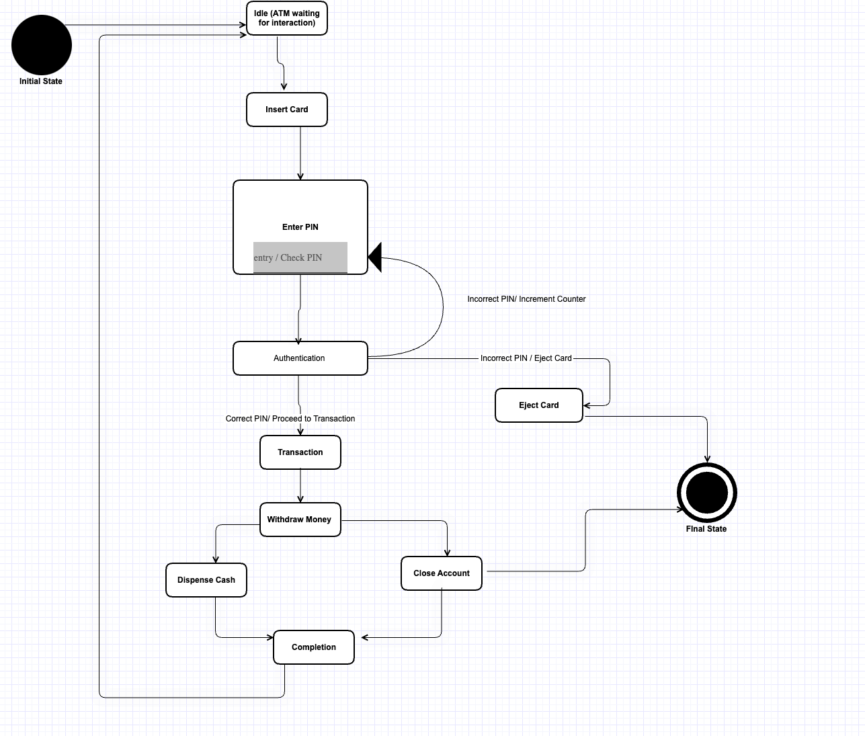

Python Script –
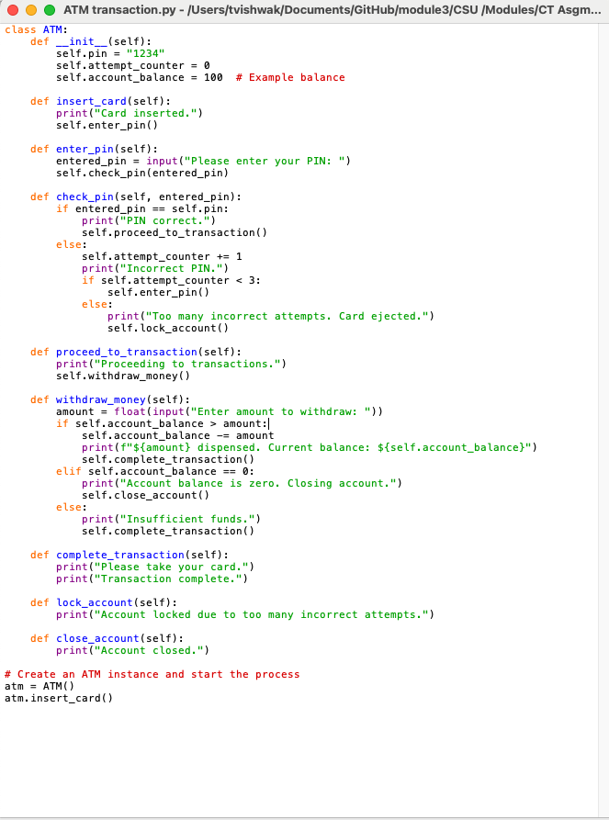

Execution-

